Test case – Buy units of gas.

The requirement fore this test is to buy 5 units of gas that is less than to total number available.

Go to <https://ensekautomationcandidatetest.azurewebsites.net/>

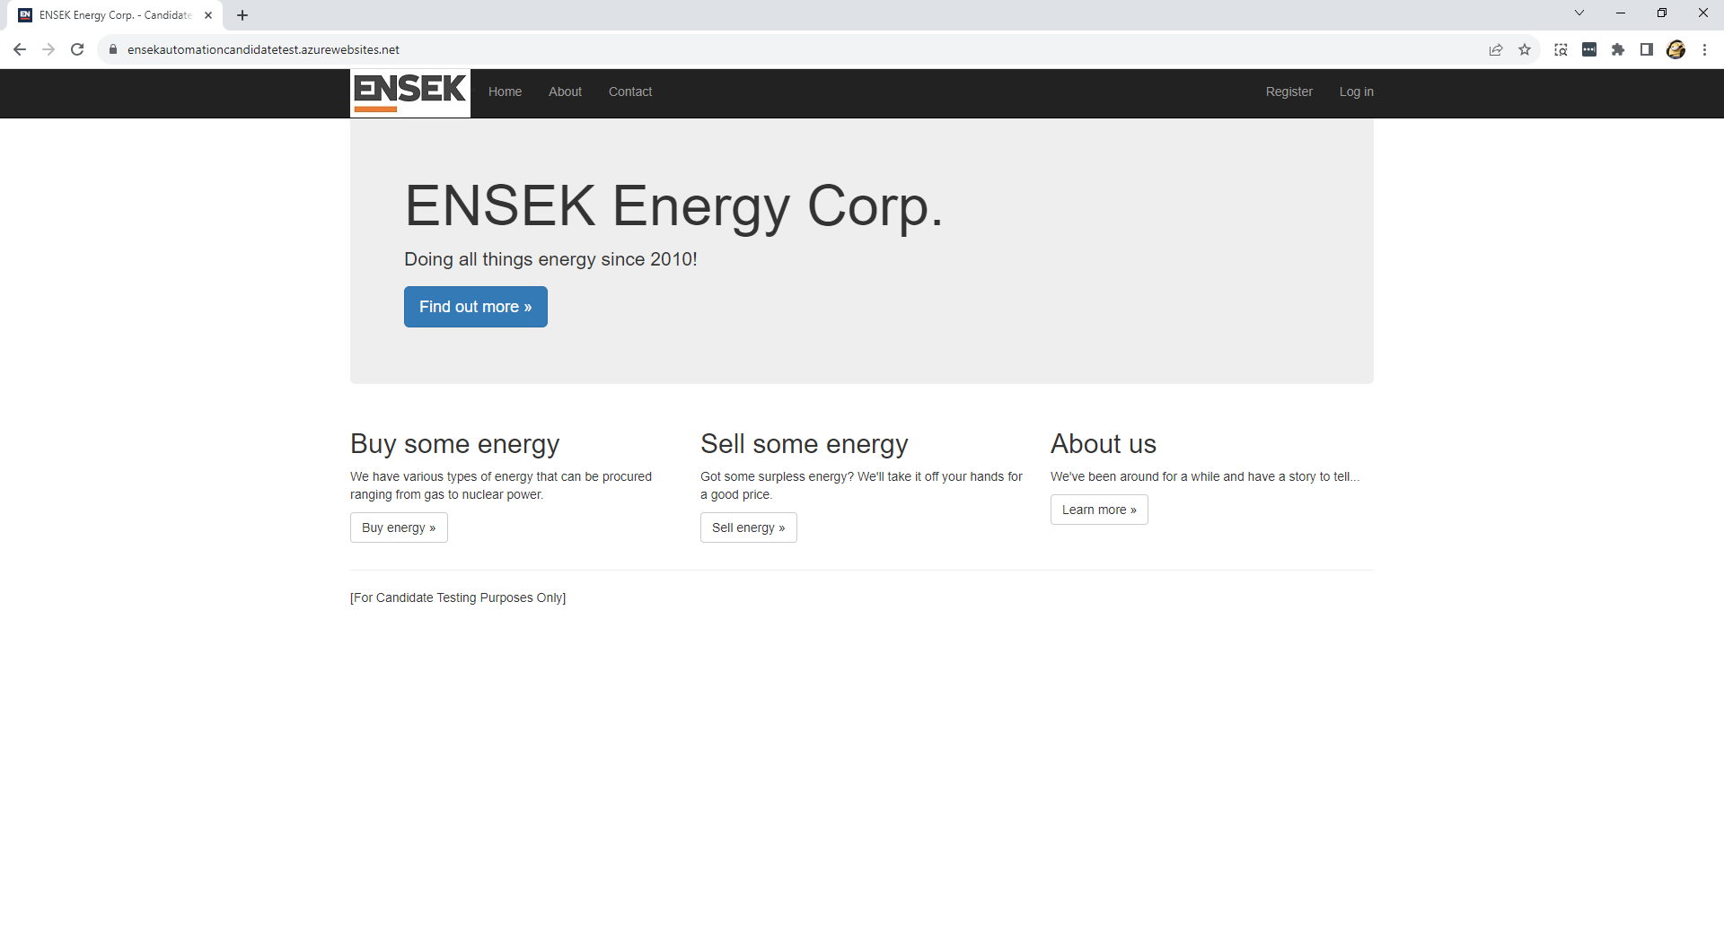

Select the buy energy button. The system will take you to the buy page <https://ensekautomationcandidatetest.azurewebsites.net/Energy/Buy>

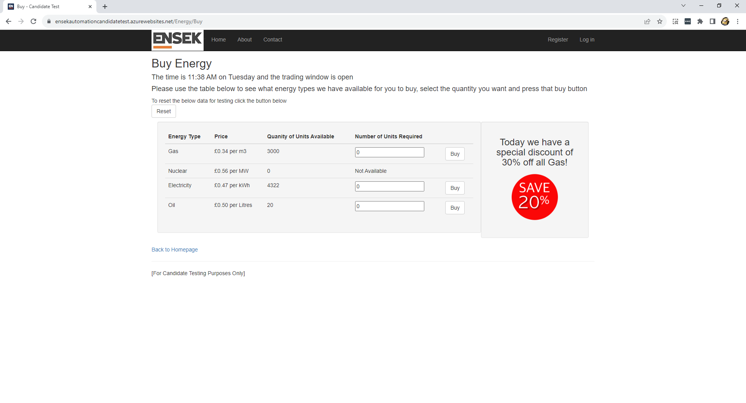

Enter a 5 in the number of units required against the gas energy type option

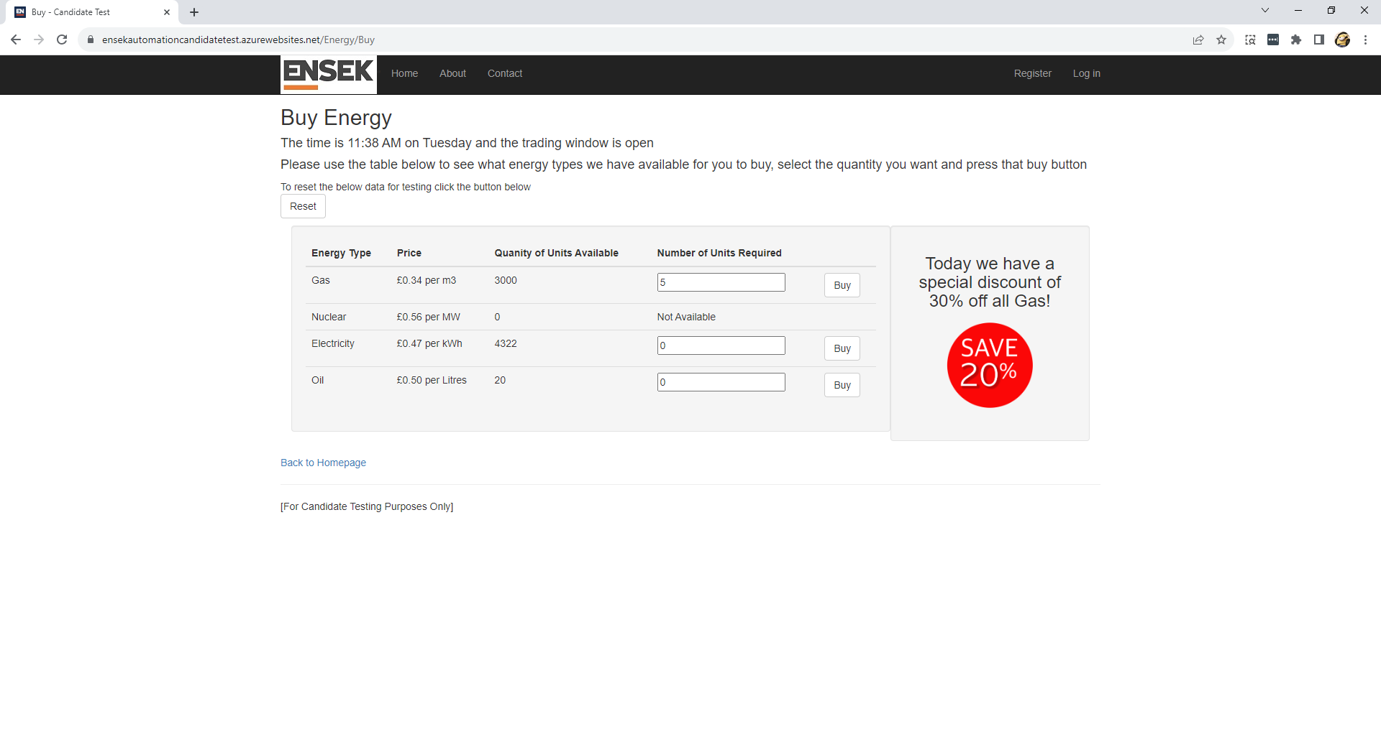

Select the buy button that coincides with the gas energy type. You will get the sale confirmed page.

